**Team Name: Fierce Tag**

**Team members:**

**Shehryar Raza – BSCS-13020**

**Abdul Jalil Mian – BSCS-13062**

**Mariyah Kaleem – BSCS-13065**

**Problem domain: Esports community app in Pakistan**

# **Introduction**

Esports industry has been revolutionized over the last decade. Many international brands and companies like Coca-Cola, Razer, American Express, etc. are investing much of their resources in esports gaming. They are organizing tournaments on an international scale, and throughout this time period, esports market is getting bigger day by day.

Our problem domain lies within the boundary of Esports industry in Pakistan. There is not a single website or an app that notifies users about nearby gaming tournaments. Moreover, we rarely see gamers’ meetup culture in Pakistan. Therefore, to promote this kind of scenarios, we proposed an idea to create an app such that it notifies users about the related gaming events in Pakistan as well as it helps different gamers from Pakistan to connect with each other via social forum available on the app.

# **Initial POV**

Our initial POV was that the gamers need a platform where they can receive notifications regarding the gaming events in Pakistan. Also, our POV had three additional things; the collective views of gamers about UI of the app, the features to be included in the app, and the feasibility of the app.

# **Additional need findings**

We went to SOFTEC gaming event held at Fast-NU from 10-11 March 2017. It is one of the biggest gaming competition in Pakistan and gamers from all around the world attend this event. We interviewed a variety of gamers (both PC and Console gamers), and almost all the gamers thought to have such an app similar to the one which we want to develop. The players saw and visualized our idea in an entirely different way since this is the first time in Pakistan that the development of esports industry is taking place. The participants in the gaming event at SOFTEC thought that there is a definite need for an automated system/app which notifies the gamers about the nearby events in Pakistan. In some cases, the gamers told us that the only platform is Facebook through which they get the information about the gaming events in Pakistan. However, there was a small issue in it; there is no notification system available on Facebook.

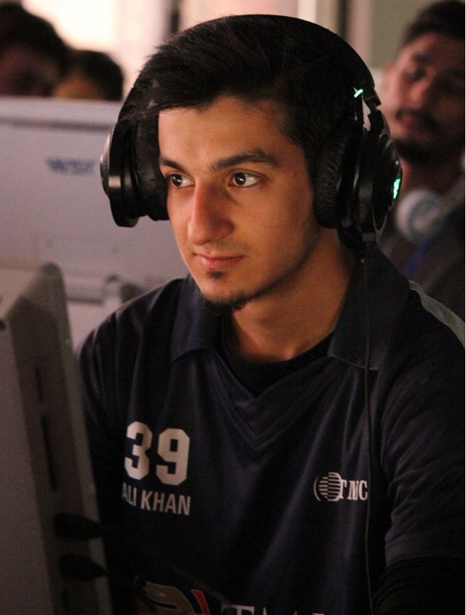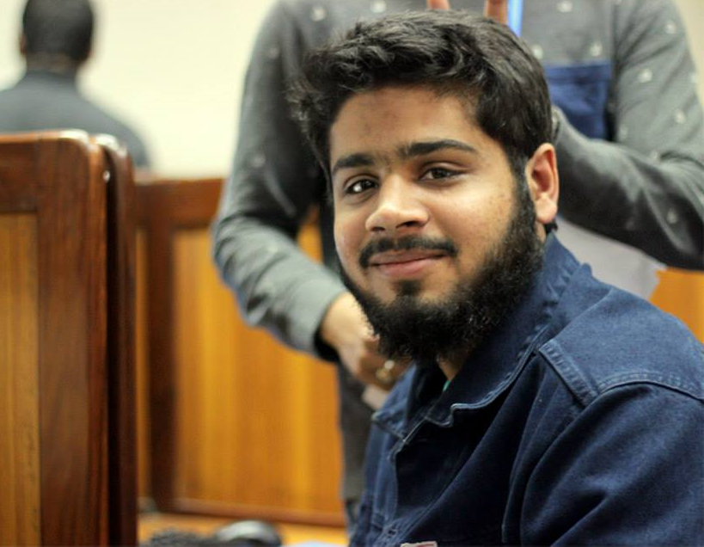

# **POV – 1**

We met the captain of Team Envy Dota 2. We were surprised to see that he has already seen an app in US, similar to what we want to develop. However, it was a multinational company and was funded with a lot of resources. It would be game changing if we could try to come up with some better solutions than the rest of the apps available for esports gaming.

# **POV – 2**

We interviewed the winning captain of SOFTEC Dota 2 and asked him about the views of esports events in Pakistan and a need for a community forum. We were surprised to see his remarks on the esports gaming app as he told us that due to his contacts with different gaming communities, he is already aware of the events nearby him. It would game changing if we could bring those event coordinators and gamers on our platform and ask them to share their events on our platform.

# **POV – 3**

We interviewed the event in-charge of SOFTEC gaming competition. We were amazed to know that for SOFTEC, some gamers and participants schedule their journey and trainings at most one week prior to the start of the main event. It would be game changing if we could gather the data and personal interests of each individual about gaming at major events and then set the organizer to notify in time.

# **HMW for POV- 1**

* How might we develop a better app than the existing one in the international market?
* How might we bring the gamers to our platform?
* How might we secure the resources that we need?
* How might we dedicate the space for the users of the app?
* How might we develop a good UI interface which attracts the Pakistan gamers?
* How might we indulge the gamers to use our app?
* How might we collect the data of various events in Pakistan?
* How might we contact the gaming event coordinators in Pakistan?
* How might we scrap the data and information of teams in Pakistan?

# **HMW for POV- 2**

* How might we make our contacts with different event coordinators and companies?
* How might we go through the contact process for gaming events?
* How might we change the current mindset of gamers for meetup culture in Pakistan?
* How might we convince different event coordinators to use our platform?
* How might we provide event coordinators a secure database to upload their data?
* How might we make a platform for gamers to rate our app?

# **HMW for POV- 3**

* How might we develop such an automated system which notifies the gamers once the official announcement is out from the organizer?
* How might we collect the data of each gamer participating in a particular tournament?
* How might we use the collected information in our app?
* How might we make this information beneficial for the rating of the teams?
* How might we develop the community forums on our app?
* How might we include the users’ demand in the community forums?
* How might we interact with the event coordinators in the community forums?

# **Three best HMW**

On the basis of strong brainstorming and collected information about esports system in Pakistan, we came to the following three best HMW questions.

* How might we develop a good UI interface which attracts the Pakistan gamers?
* How might we improve the community forums on our app?
* How might we provide event coordinators a secure database to upload their data?

# **Solutions for HMW - 1**

For the first part of the problem, we came to the following solutions.

* Conduct surveys from gamers and ask them about what do they like in an app for gaming events.
* Observe the information and collectively use it for the UI of the app.
* Observe different choices of each gamer and provide them the ability to change the UI of the app accordingly.
* Design a proper UI which resembles the past of esports gaming in Pakistan.
* Give the access to the users to change the current background or color icons of the main menu in the app.

# **Solutions for HMW - 2**

For the second part of our problem, we came up with multiple solutions.

* Based on the information gathered, make a forum and then make a choice for the user to enter into a particular forum.
* Ask a user to answer a few questions and on the basis of these issues, automatically add the user to the community forum of the particular game.
* Make a section for feedback and FAQs.

# **Solutions for HMW - 3**

For the third problem of our domain, we came up with the following solutions.

* Give a secure accessibility.
* Give an option for event organizers to add details of their event with encrypted data.
* Contact the event coordinator and establish good relations with him/her.

# **Three best solutions**

From the existing solutions, below are the top three solutions that we think are optimal for our problem domain.

* Give the access to the users to change the current background or color icons of the main menu in the app.
* Give an option for event organizers to add details of their event with encrypted data.
* Make a section for feedback and FAQs.

# **Experiencing prototypes**

# **Prototype 1**

Based on our first solution provided in the above list, a user can change the current background picture or color icons of the main menu in our app. The basic idea behind this solution is to give freedom and space to the user and prioritize the user experience as much as we can.

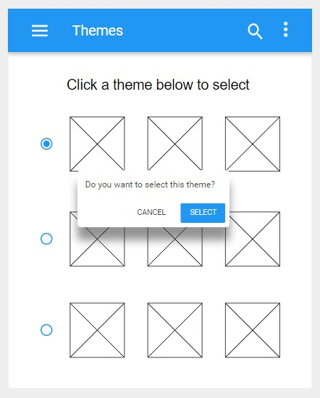

Based on an online application known as Moqups, we built the prototype on that software to maximize the usage of our app.

As far as the testing of our prototype is concerned, we went to SOFTEC and tested our prototype with the different type of gamers. Almost all of the gamers liked the concept of such an app, and the feedback we received was very positive.

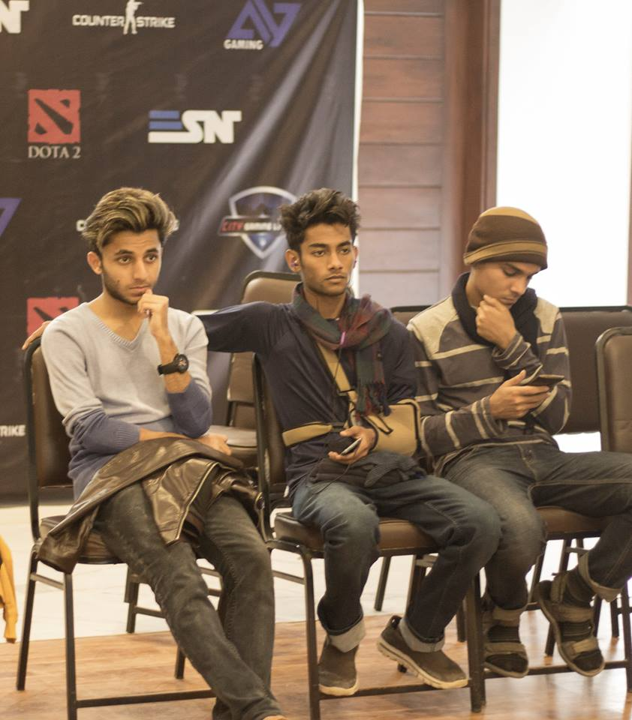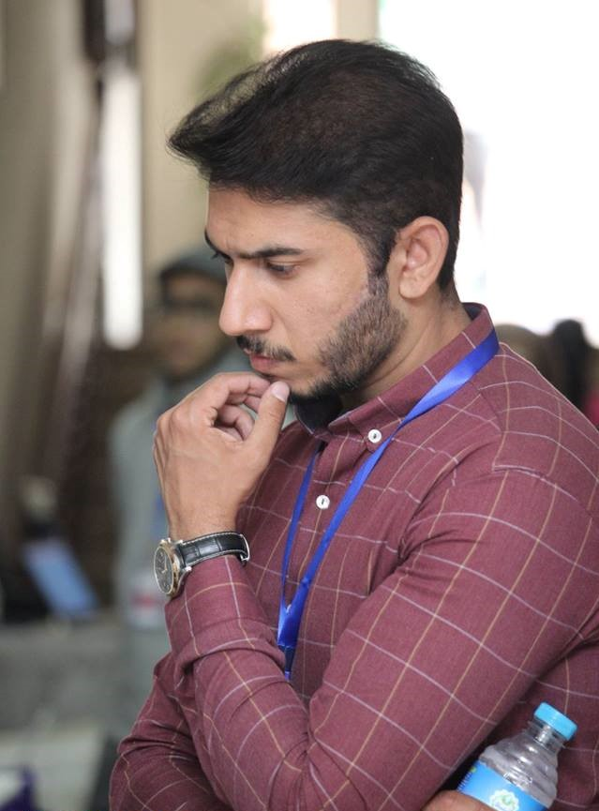

# **Prototype 2**

Giving the freedom to organizers to add their relevant gaming events on our app will not only make things easy for us, but it will help the organizers to spread the words across Pakistan. Just like the first prototype, we used Moqups online tool to make our prototype.

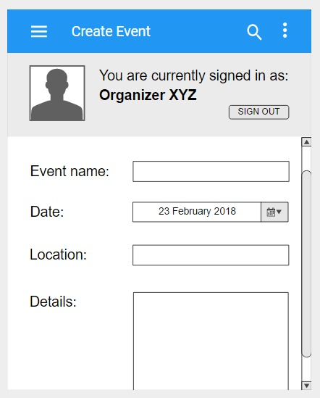

We went to different gaming zones and tested our prototype with the organizers. Like the result of the first prototype, we received positive feedback from the organizers, and they left a remark that such type of application will definitely help us (the organizers) to spread the event in the general gaming community of Pakistan.

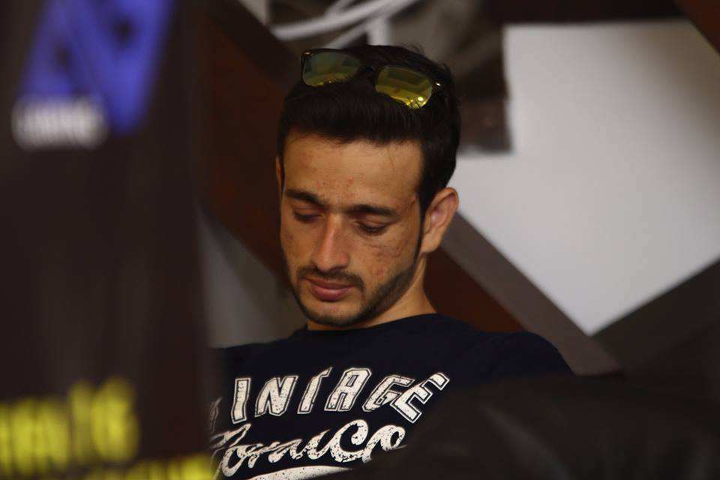

# **Prototype 3**

The need for this section was definitely needed because technically, it will be the first esports app in Pakistan. Therefore, to clarify individual queries of the users should be the top priority and thus, the need for this section was optimized in the list of solutions.

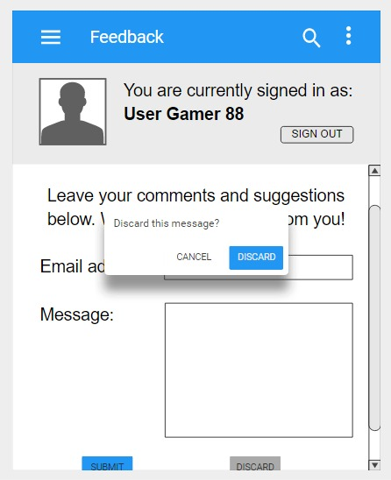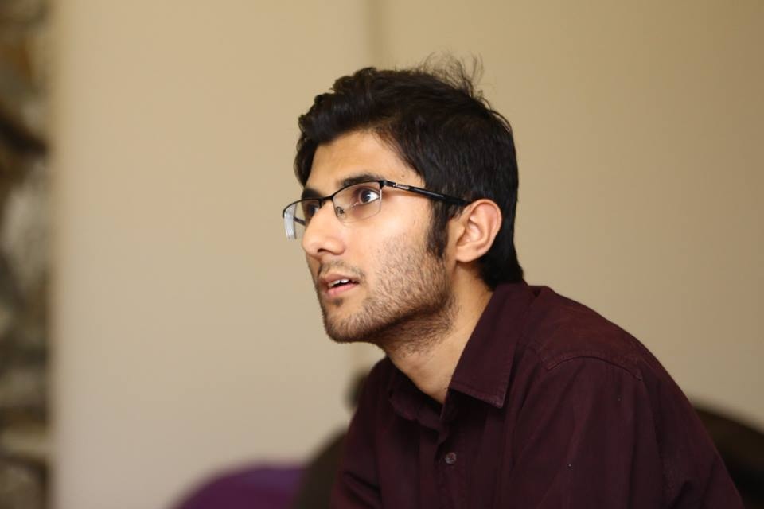

Out of all the prototypes, the solution for event organizer was much more successful. The feature has multiple options for the event organizers and using the app, they will get one huge benefit i.e. get more players on the event.